**Automate the following UI scenarios.**

**Please use modular coding to do the same.**

**Once done, please host the code on your public repo on github with readme explaining detailed steps to run and it’s requirement.**

1. Go to url :<http://quickfuseapps.com/>
2. Click on Create an App

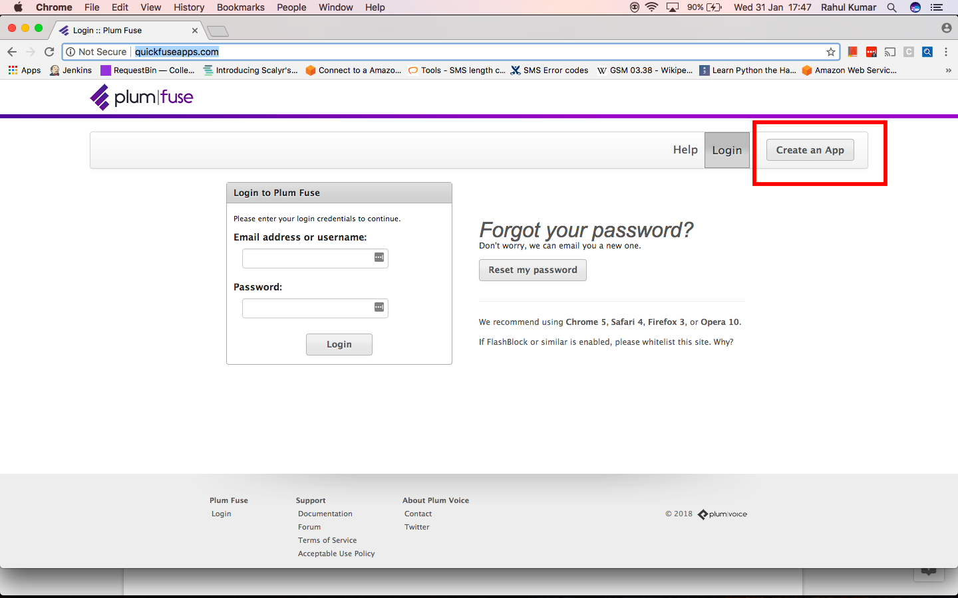

3. You will land up on default page and then click “Lets’ get started” :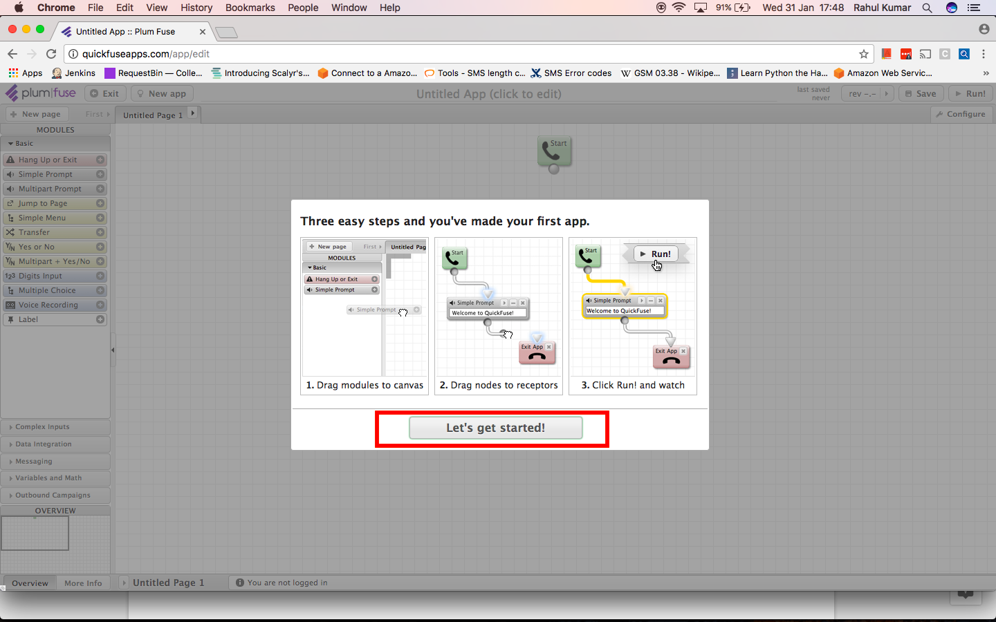

4. Create a new page and give it a name

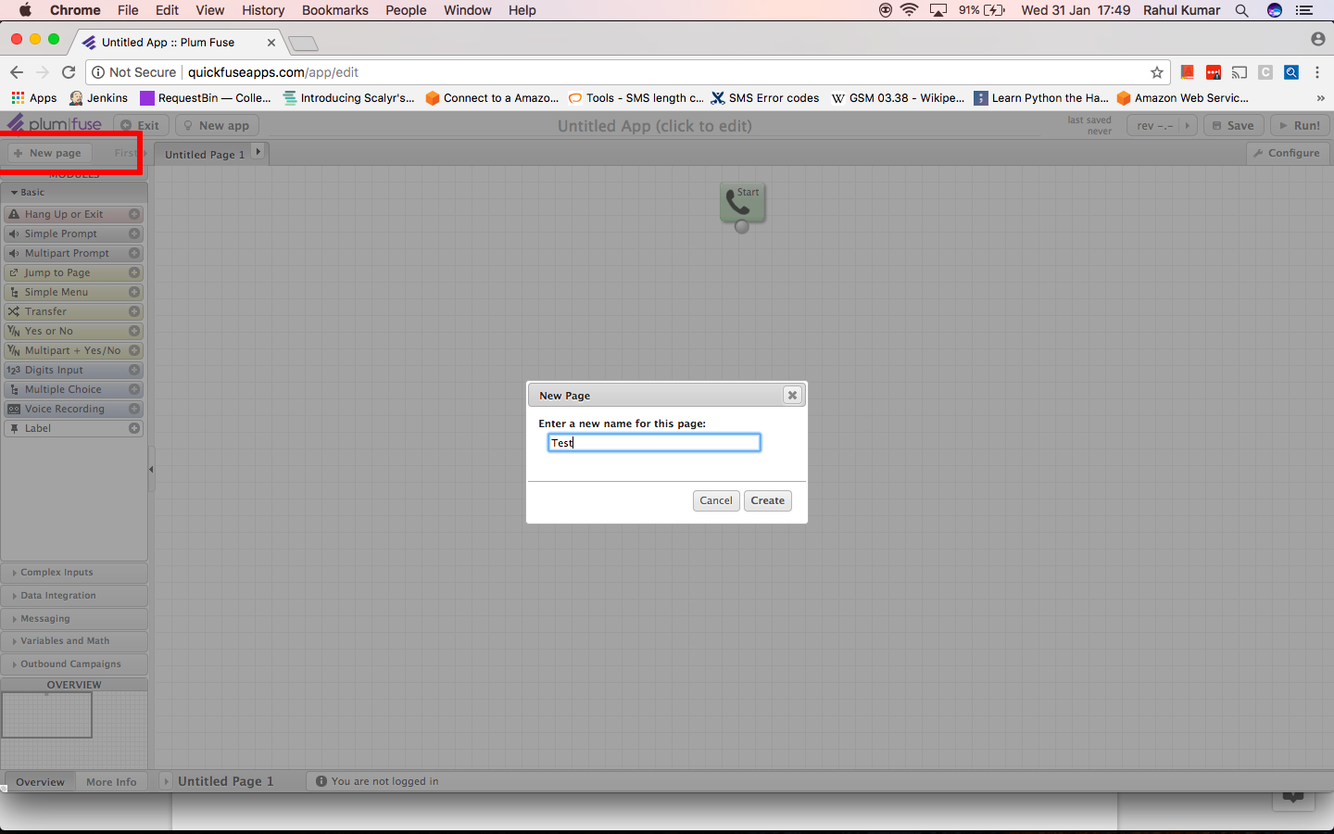

5. Click on “Messaging” group appearing on the left pane under MODULES :

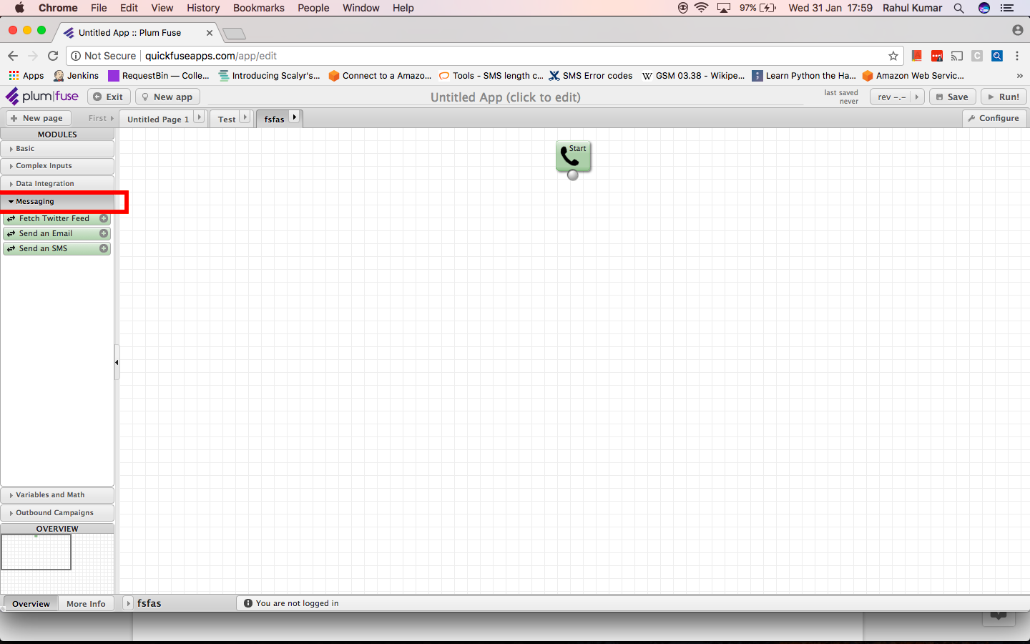

6. Drag component “Send an SMS” to the main app page & join the line from start acting as connector :

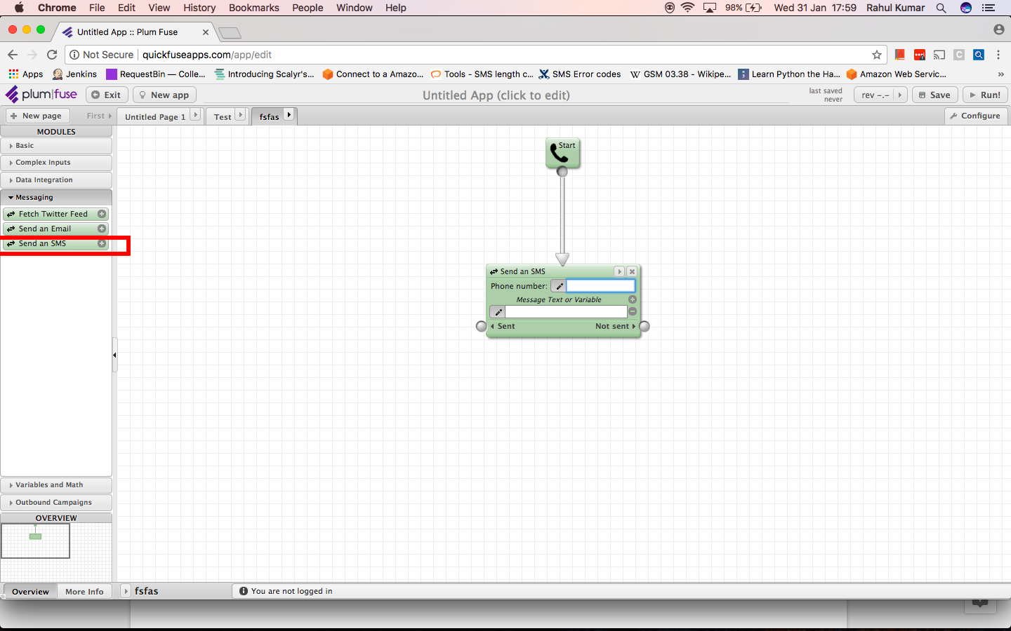

7. Fill the details of Phone Number and Message text :

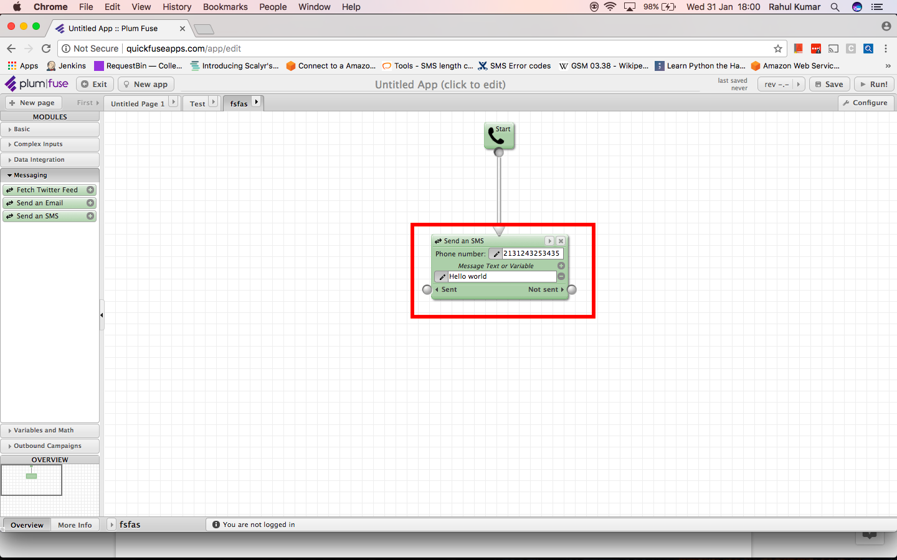

8. Drag component “Send an email” from the left module and join line from “Not sent” output port.Also fill all the details of the mail as shown :

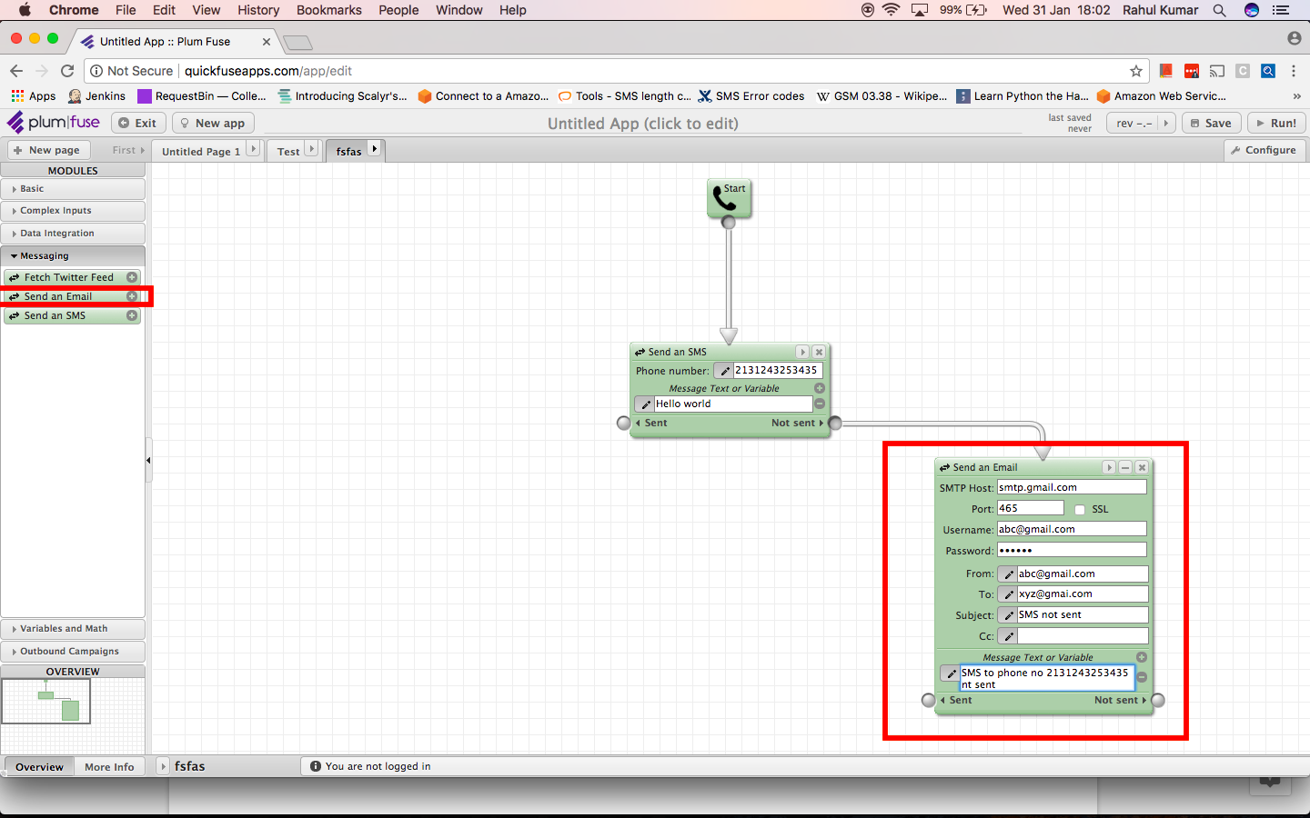

9. Click on component “Basic” on left Module and drag “Exit App” joining to “Sent” output port of Sent an sms box :

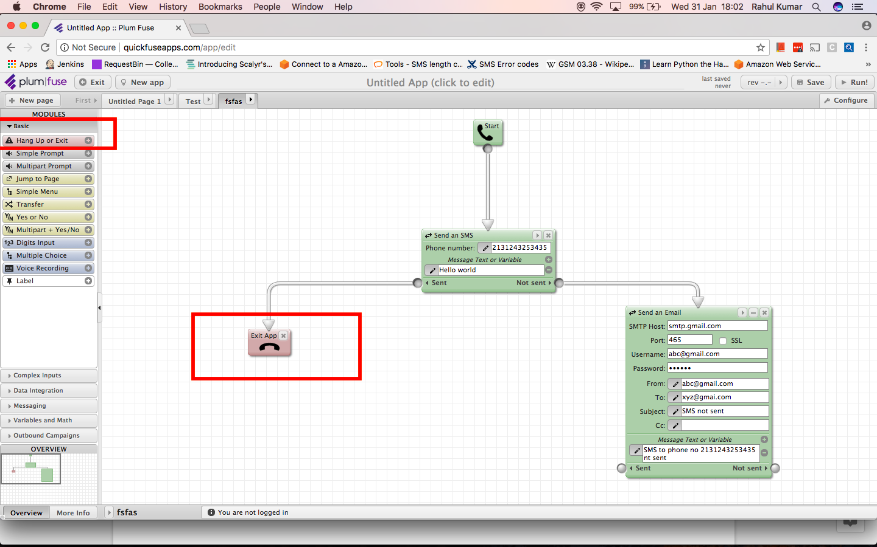

10. Similarly, Join all the open output ports of “Send an Email” to Exit app by dragging :

